**MariaDB Assignment**

**Problem Statement:**

**You work for XYZ Corporation. Their application requires a SQL service that can store data which can be retrieved if required. Implement a suitable RDS engine for the same. While migrating, you are asked to perform the following**

**tasks:**

**1. Create a MariaDB Engine based RDS Database.**

**2. Connect to the DB using the following ways:**

**a. SQL Client for Windows**

**b. Linux based EC2 Instance**

1. Create a MariaDB Engine based RDS Database

Creating RDS Database.

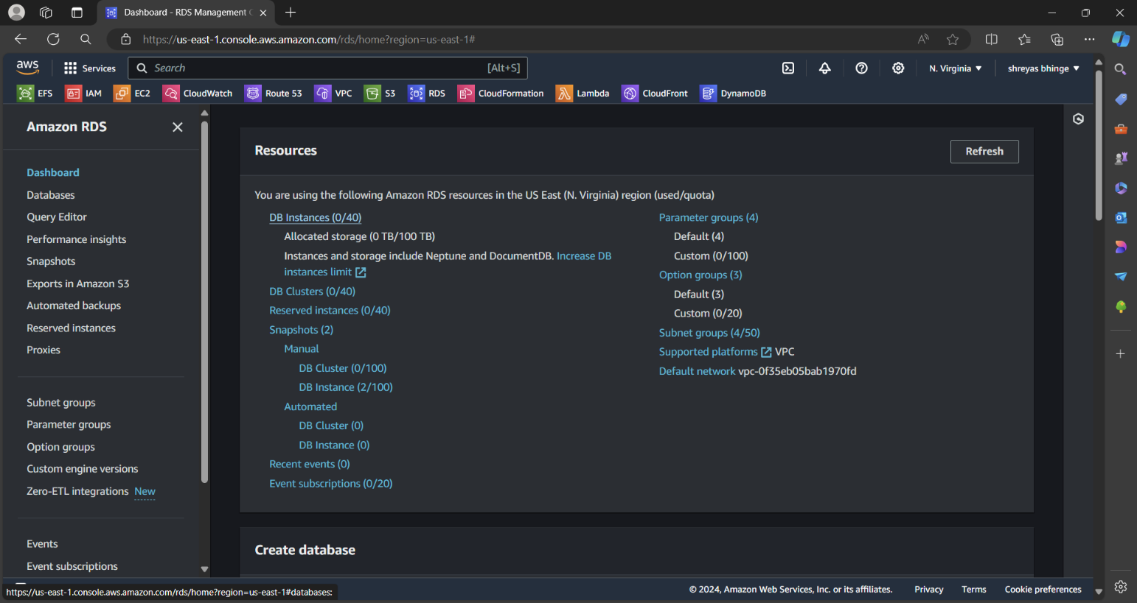

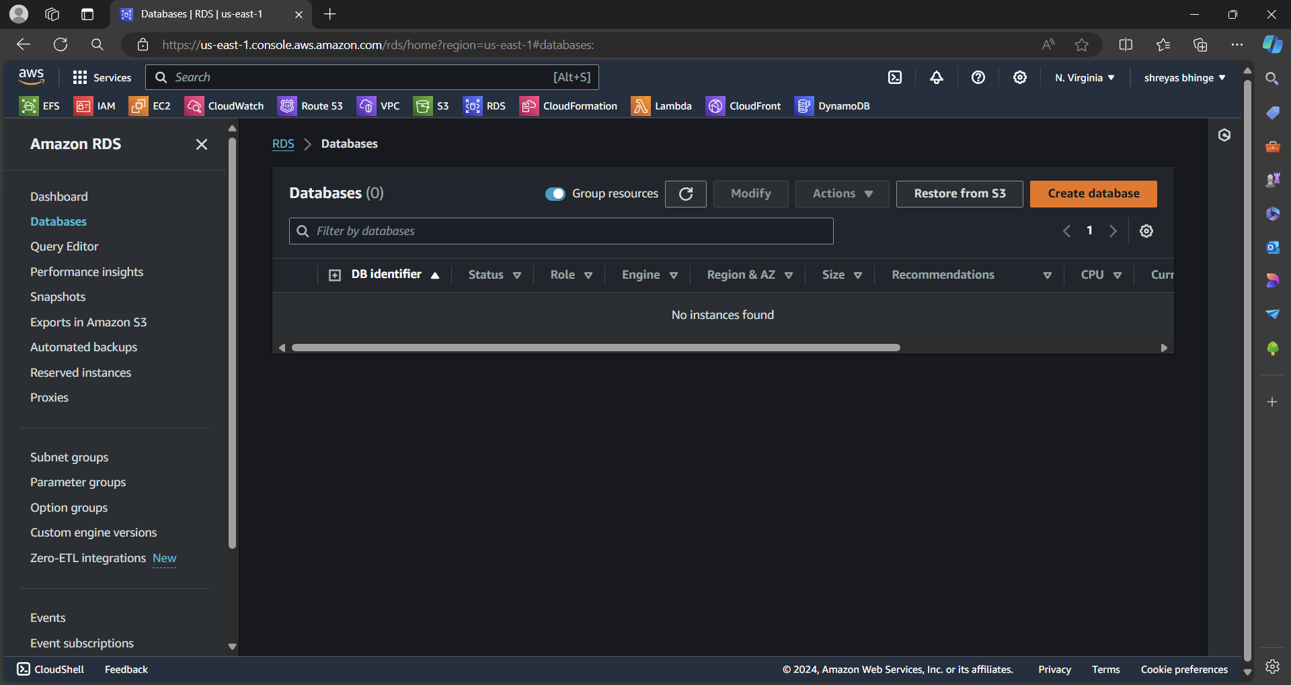

Choose data option Standard and engine option Maria DB

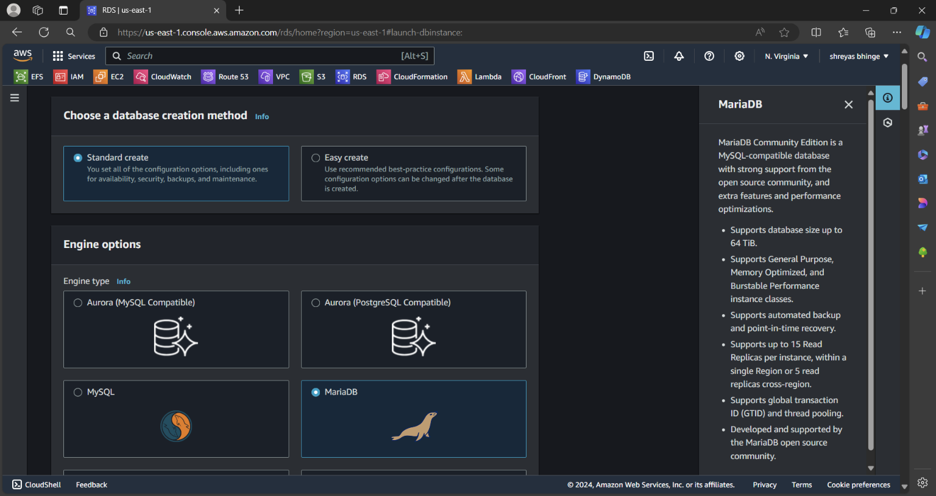

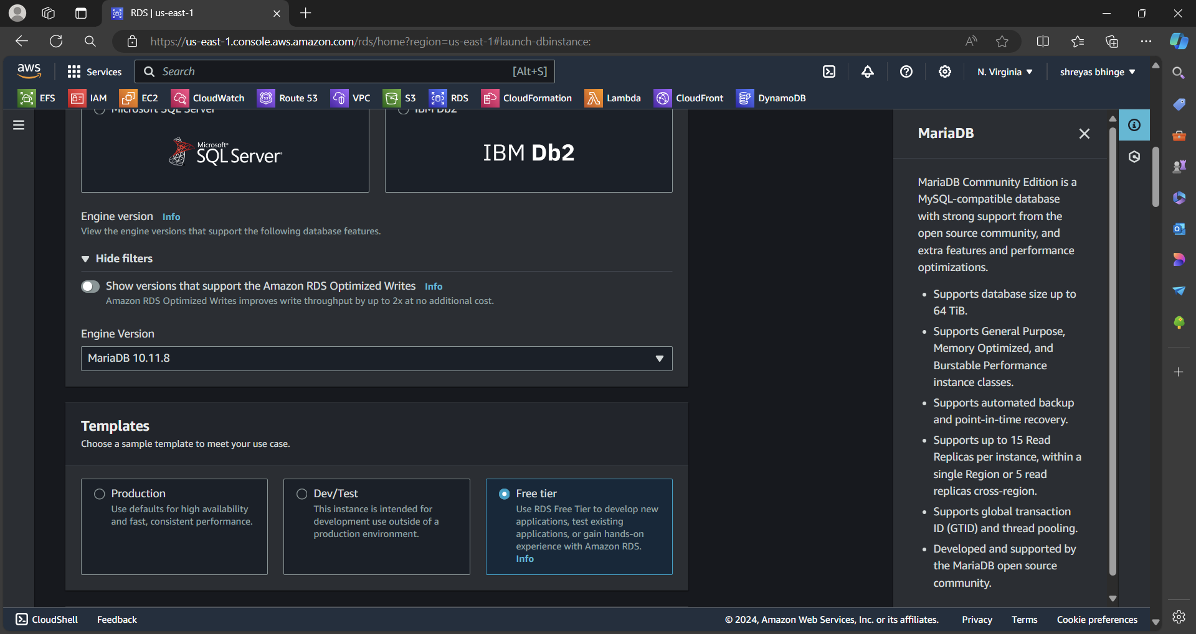

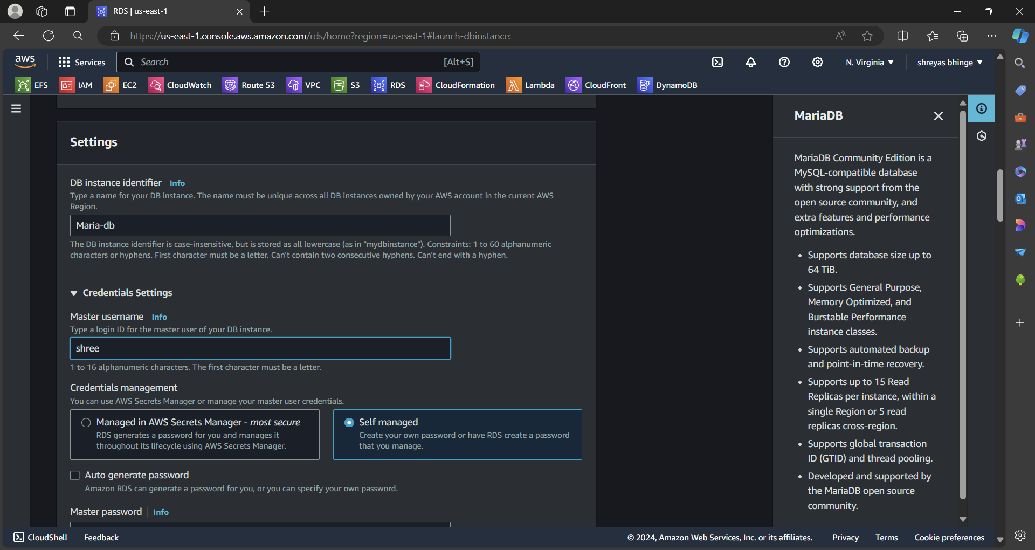

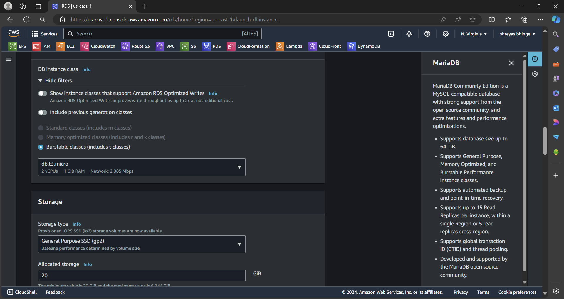

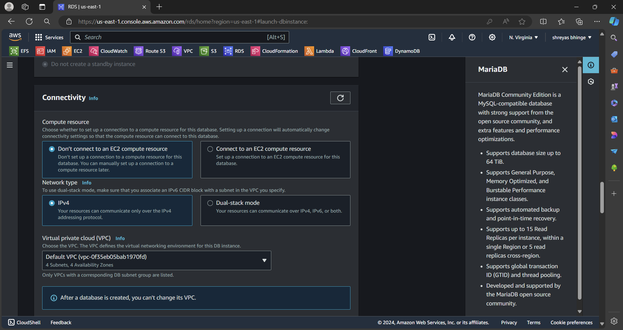

Allow Public access

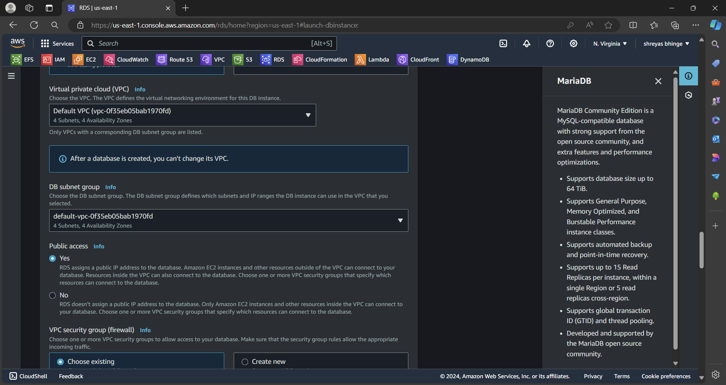

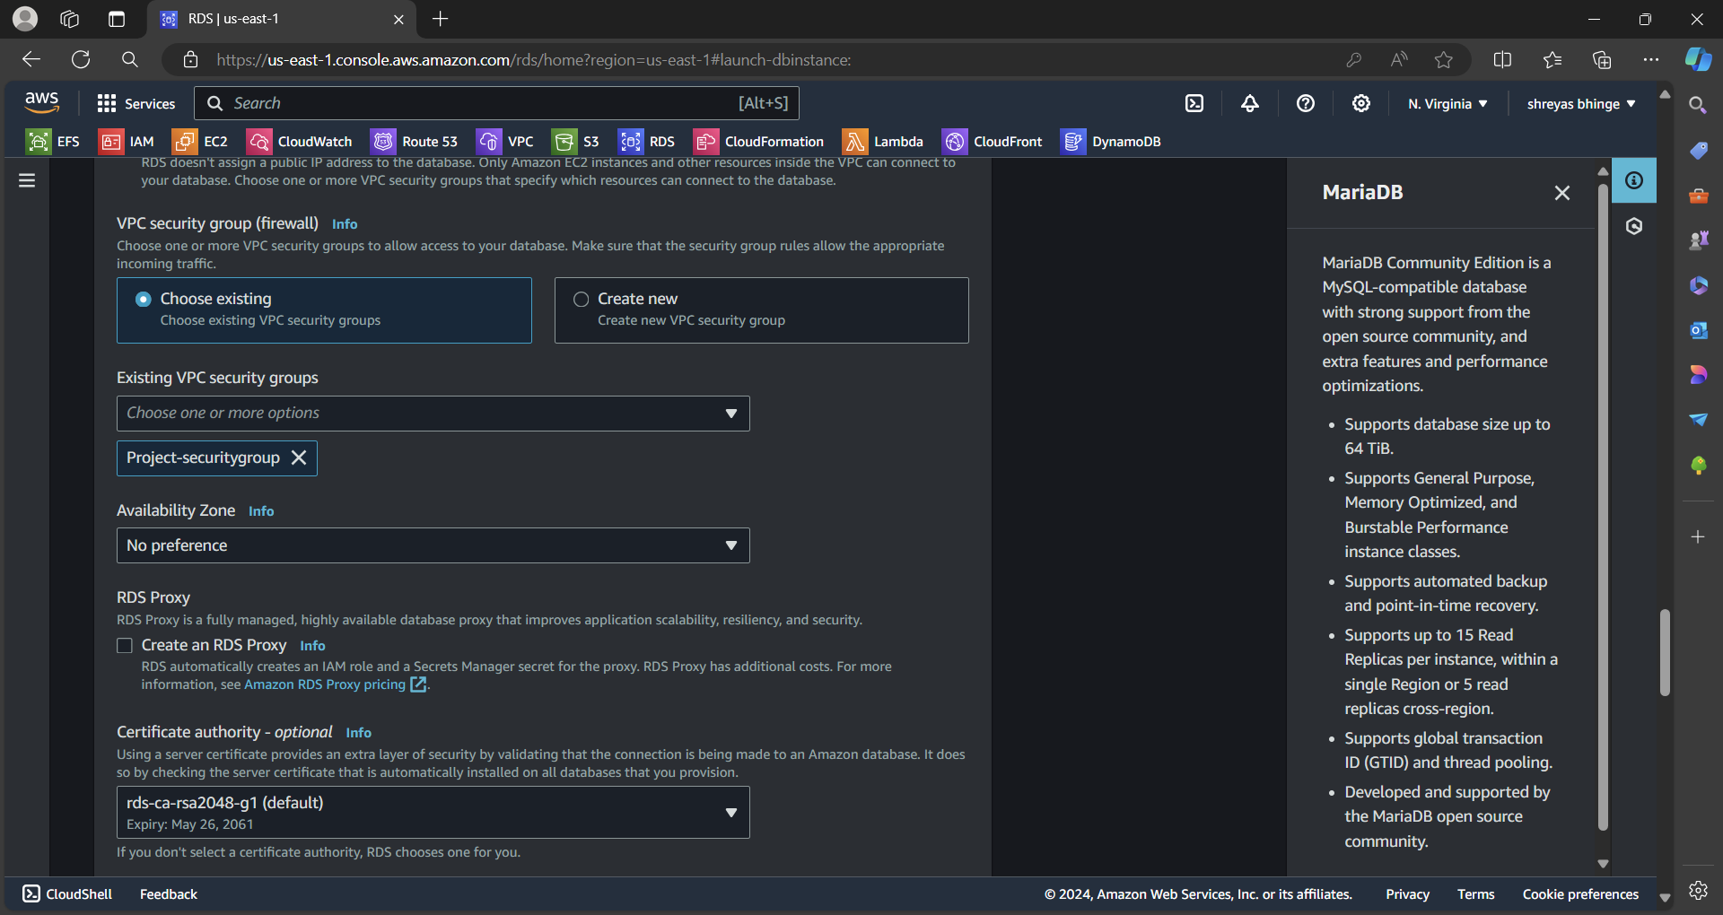

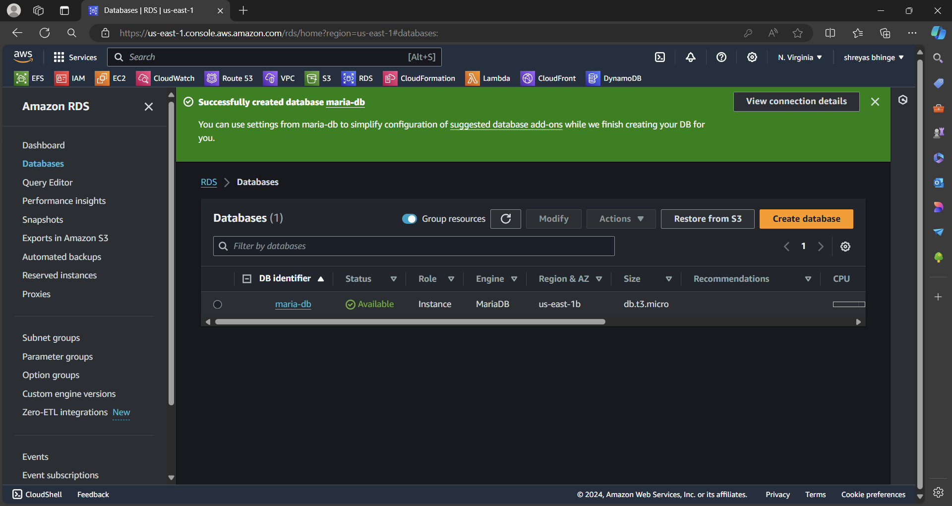

2. Connect to the DB using the following ways:

a. SQL Client for Windows

* Opened MySQL Work-Bench
* Added new connection
* Connection method User/password
* Entered Hostname i.e Endpoint
* Password of Database
* Checked Connection
* Connected

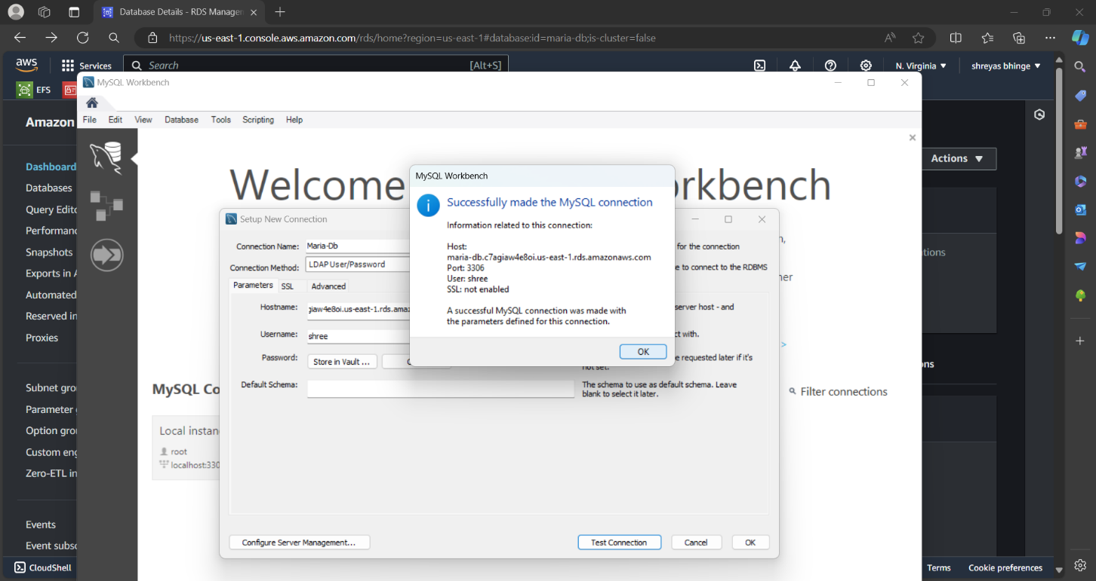

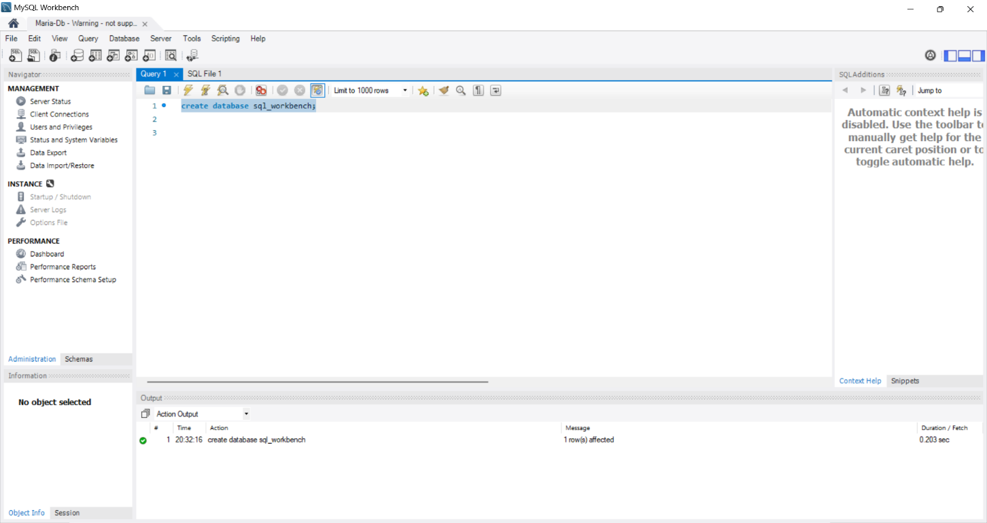

b. Linux based EC2 Instance.

Created EC2 Instance

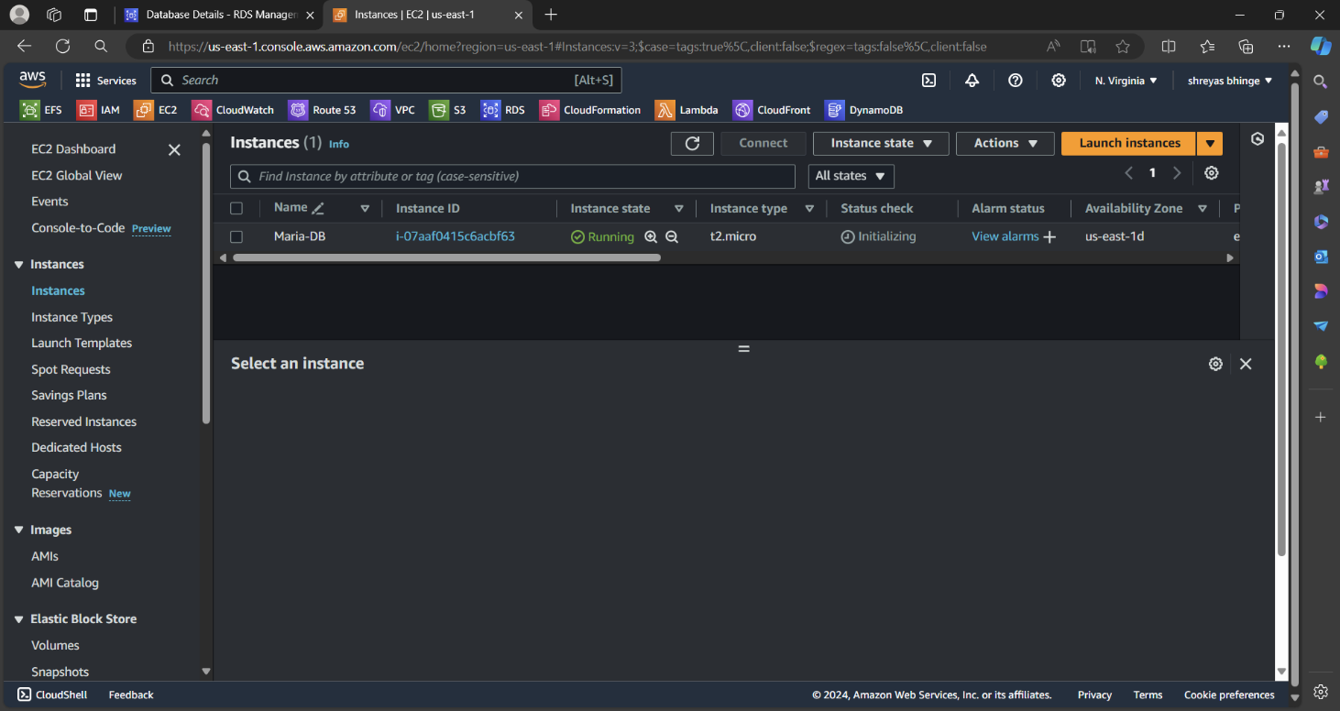

Connect EC2

* Sudo yum update
* sudo dnf update -y
* sudo dnf install mariadb105
* mysql -h Endpoint -P 3306 -u admin -p

